RESONANT TRANSMISSION LINE
Objective: To observe the resonance of a transmission line with both a short and an open
circuit termination.

List of Equipment:

- Transmission Line Demonstrator (TLD)
- Sine wave generator
- Oscilloscope

Theory
When a line was terminated by any other impedance than the characteristics one, a signal on the line was reflected. In a real line, energy is associated with the reflected signal. Suppose that both ends of the line are terminated so that they absorb no energy and that energy losses in the line are small. Any signal on the line must then be totally reflected back and forth between the two ends. By terminating the line with an open and a short mismatching is obtained.

Line short-circuits both ends – In this arrangement a short is applied in both side of line after energizing it. For different lengths of line it shows series or parallel resonance. If RF of a slightly lower frequency is applied, the electrical length of the line decreases below a half wavelength and the input impedance is capacitive. If the frequency is increased, the input impedance is inductive. Thus the short circuited half wave line acts like a series resonant circuit. Similarly a quarter wave line can also be used in place of resonant LC circuit. The open circuited quarter wave line acts like a series LC circuit.

Line open-circuit both ends – In this arrangement an open is applied in both side of line after energizing it. If RF of a slightly lower frequency is applied, the electrical length of the line decreases below a half wavelength and the input impedance is inductive. If the frequency is increased, the input impedance is capacitive. Thus the short circuited half wave line acts like a series resonant circuit. Similarly a quarter wave line can also be used in place of resonant LC circuit. The short circuited quarter wave line acts like a parallel LC circuit.
Procedure:
a) Line short-circuit both ends
- Click the “Run continuously” button to run the experiment.
- Connect the source to Transmission line demonstrator as shown in figure1. The ends of TLD have been terminated by short and low impedance.
- Change the frequency of the source by slider and amplitude by using knob given in Source window. “Delay Time” is an option for delay, given in Transmission line demonstrator window.
- The electric length (i.e. quarter wavelength, half wavelength & full wavelength etc) of the line can be changed by varying the frequency of source.
- Maxima can be obtained in both of the end for some lengths. Find those frequencies.

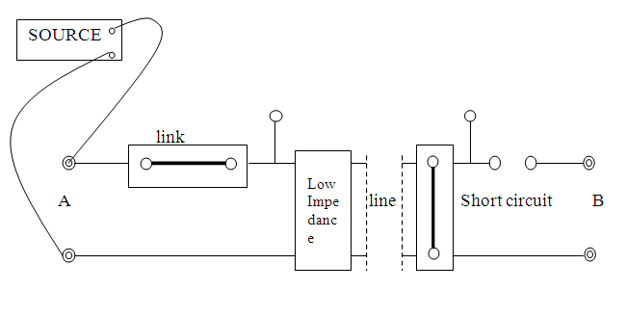
Figure 1. Experimental setup for the short circuited line

b) Line open-circuit both ends

- Click the “Run continuously” button to run the experiment.
- Connect the source to Transmission line demonstrator as shown in figure 2. Both the ends of TLD have been kept open.
- Change the frequency of the source by slider and amplitude by using knob given in Source window. “Delay Time” is an option for delay, given in Transmission line demonstrator window.
- The electric length (i.e. quarter wavelength, half wavelength & full wavelength etc) of the line can be changed by varying the frequency of source.
- Minima can be obtained in both of the end for some lengths. Find those frequencies.

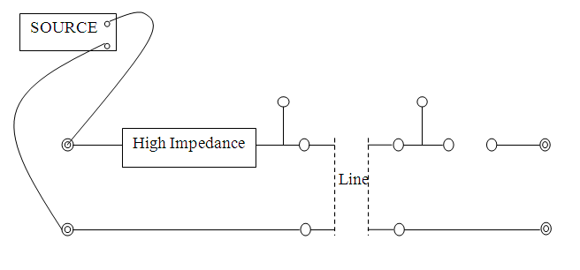
Figure 2. Experimental setup for the open circuited line

Discussions:
- How do you come to know that the particular line is series or parallel resonant circuit?
- What statement can you make about the shape of the voltage wave in case of line terminated in a short?
- Where the voltage maximum is obtained in case of line with open circuit ends?

References:
- E.C. Jordan and K.G.Balmain, ‘Electromagnetic wave Radiating Systems’ 1968.
- A.W. Cross, ‘Experimental Microwaves’, 1977.
- Mathew N. O. Sadiku, “Elements of Electromagnetics”, Oxford University Press, 2001.

